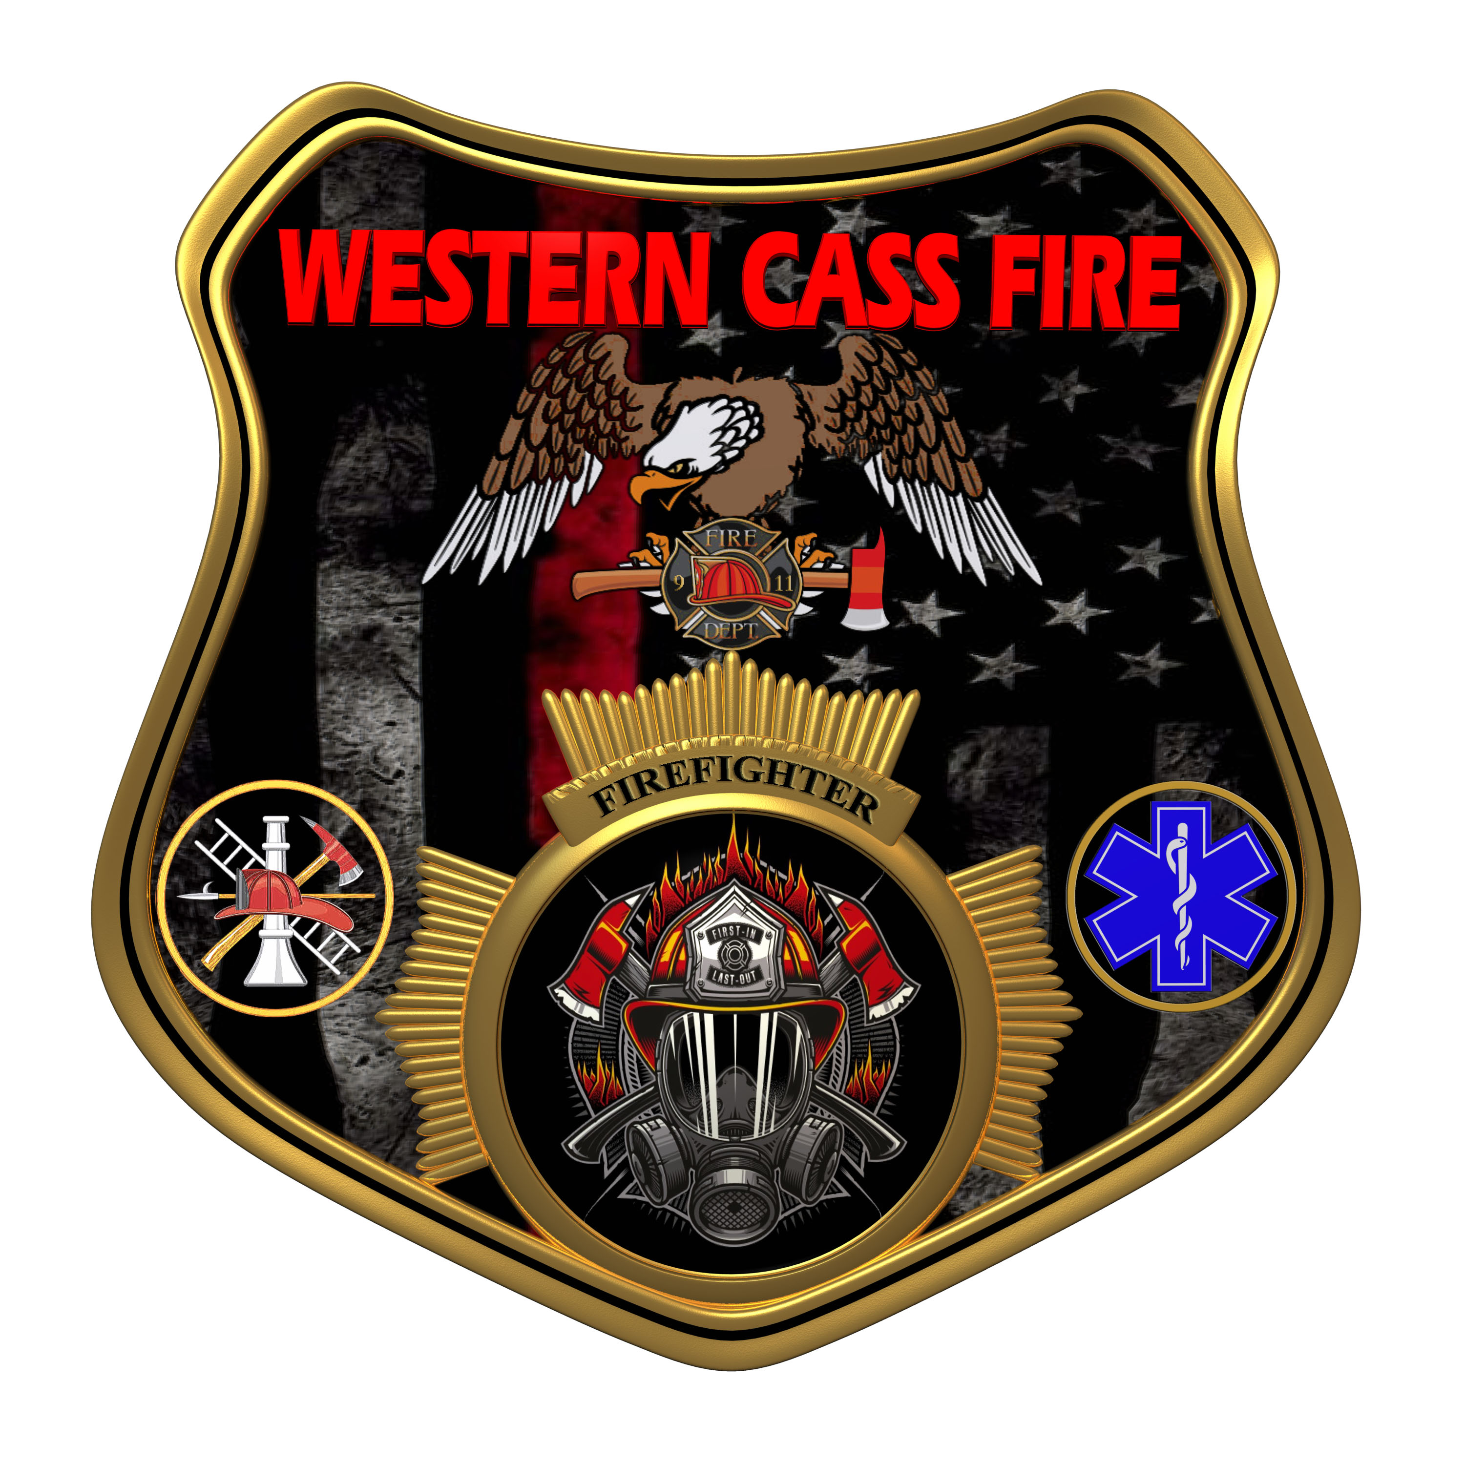 | Tentative Agenda  Western Cass Fire Protection District  Regular Session Meeting  Wednesday September 18, 2024, at 7:00 P.M.  Fire Headquarters  5 S. Rogers Road, Cleveland, MO 64734  Discussion Protocols and Organization Rules for Meetings:  Questions from the public must be in writing with the following information: Name, Phone #, Physical Address, Email Address.
- Call to Order by the Secretary
- Pledge of Allegiance
3) Roll Call (Quorum)
a) President Sue Hosterman (2019-2025)
b) Vice Chair John Webb (2022- 2027)
c) Director Tom Reintjes (2023- 2029)
d) Director Theresa Hawkins (2020-2025)
e) Director Mike Bigg (2021-2027)
4) Approve the Regular Session Meeting Tentative Agenda and Additions
5) Public Comments
6) Approve the August 21, 2024 Regular Session Open and Closed Minutes
7) Reports
8) New Business
a) 2024 Budget Amendment and Categorization
b) Uniforms
c) 2025 Proposed Budget Review
9) Unfinished Business
10) Closed Session: Legal
Litigation matters are confidential until such time as they may be made public by the Board of Directors, and the nondisclosure of such records outweighs the public interest in disclosure of the records as according to RSMo 610.021(1)(3)(13)(19).
11) Return to Open Session
12) Adjourn

