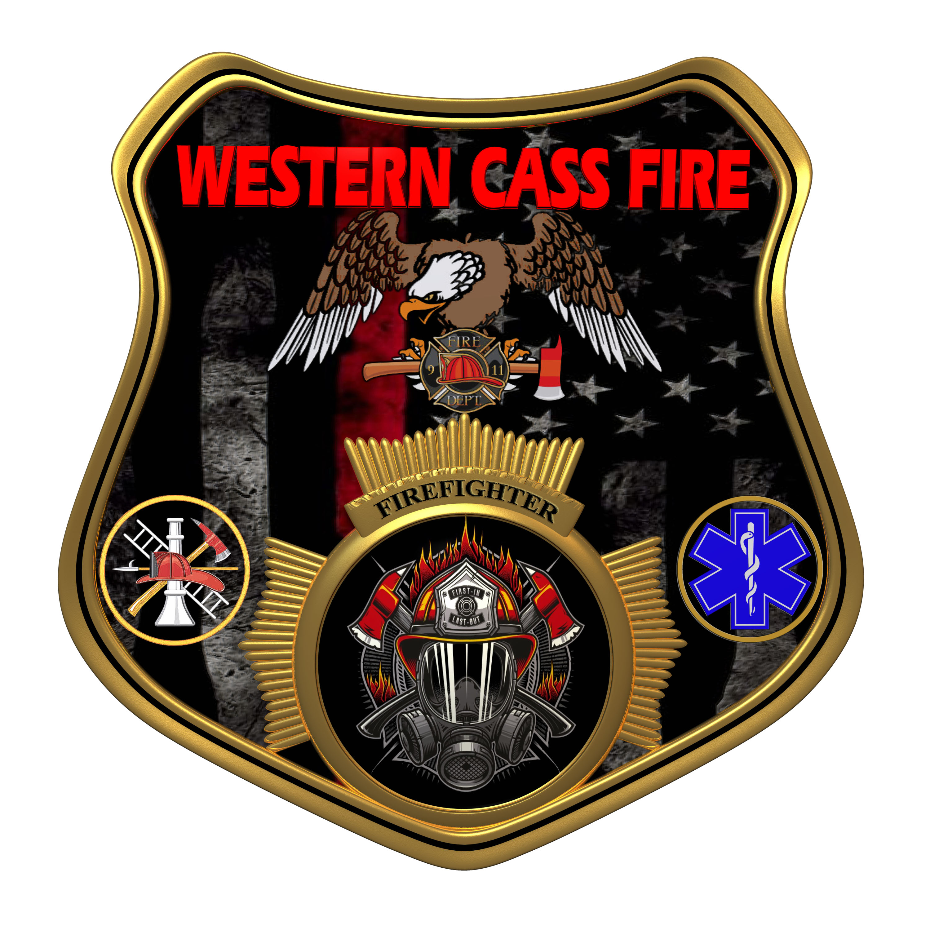 | Tentative Agenda  Western Cass Fire Protection District  Regular Session Meeting  Wednesday July 17, 2024 at7:00 P.M.  Fire Headquarters  5 S. Rogers Road, Cleveland, MO 64734  Discussion Protocols and Organization Rules for Meetings:  Questions from the public must be in writing with the following information: Name, Phone #, Physical Address, Email Address.
- Call to Order by the Secretary
- Pledge of Allegiance
3) Roll Call (Quorum)
a) President Sue Hosterman (2019-2025)
b) Vice Chair John Webb (2022- 2027)
c) Director Tom Reintjes (2023- 2029)
d) Director Theresa Hawkins (2020-2025)
e) Director Mike Bigg (2021-2027)
4) Public Comments
5) Approve the July 17, 2024 Regular Session Meeting Tentative Agenda and Additions.
6) Approve the June 19, 2024 Open and Closed Session Minutes, and the July 08, 2024 Work Session Minutes.
7) Reports
8) New Business
9) Unfinished Business
a) Work Session
b) Seal Coat Station 2
10) Closed Session: Legal
Litigation matters are confidential until such time as they may be made public by the Board of Directors, and the nondisclosure of such records outweighs the public interest in disclosure of the records as according to RSMo 610.021(1)(3)(13)(19).
11) Return to Open Session
12) Adjourn

